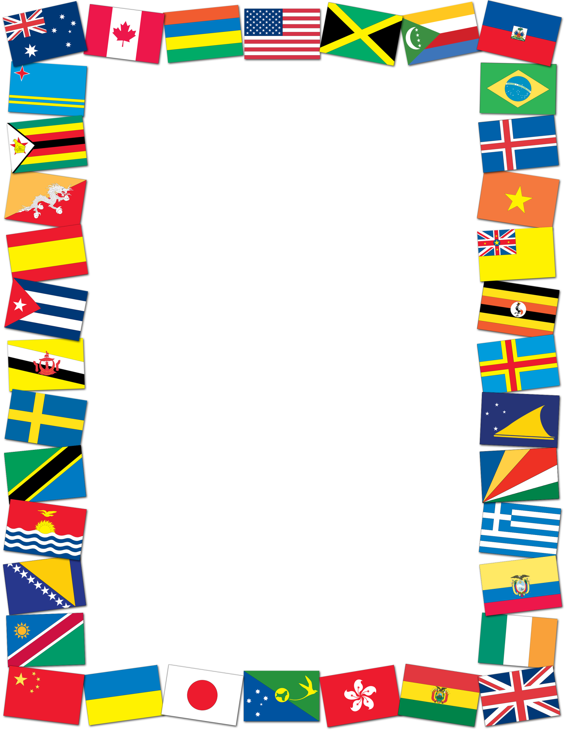

**“Traditions Around the World”**

**Lovejoy Culture Fair**

**Thursday, May 11th from 5:30p-7:30p**

**Learn about traditions and try food samples from different parts of world!**

This year families will visit- **Guatemala, Nepal, Mexico, El Salvador, Laos, & Myanmar.**

Families will not only visit all these countries, but will also have the opportunity to participate in an activity from each country!

Tickets for food samples will be available at the front door then please report to your eldest child’s classroom for scheduling information.

We look forward to having all Lovejoy students and their immediate family members join us!